SIMATS ENGINEERING
Department of Information Technology
ITA05 – Computer Vision

ASSIGNMENT 2 – CO2
Apply, Compare and Justify Image Enhancement and Segmentation Techniques for a Smart Document Scanner for the College Library
CO2: Apply image enhancement and segmentation techniques for extracting meaningful regions from images.

Student Name | A SHASANK | Register Number | 1972260110
Department / Section | Information Technology | Academic Year / Semester | 2025-2026
Faculty Name | Dr.P.Murali | Nature of Assignment | Individual
Duration | 1 Week | Total Marks | 50
Date of Submission | 05\11\2026 | Date of Evaluation

MARK SHEET (Rubric-based Evaluation)

Task | Task Title | Max | Marks Awarded | Remarks
1 | Grey Level Transformation Analysis | 4 | 3.5 | Three transformations on 10 pages; contrast  39.5 → 69.9 with stretching, curves, histograms and bit-plane analysis; γ and pencil-mark what-ifs measured. Pretrained enhancement model reasoned, not run.
2 | Histogram Processing and Enhancement | 4 | 3.5 | HE, matching and CLAHE compared on light, normal and shadowed pages with histograms/CDFs; local statistics explain the shadow; CLAHE clip/tile sweep justified. Deep model comparison not run.
3 | Spatial Filtering and Image Smoothing | 5 | 4.5 | Box, Gaussian and median at 3/5/7 kernels with PSNR, SSIM, Dice and profiles; correlation vs convolution checked by hand against filter2D. DnCNN / diffusion reasoned only.
4 | Image Sharpening and Edge Enhancement | 5 | 4.5 | Laplacian, unsharp/high-boost and gradient sharpening with variance of Laplacian, blank-paper noise, halos and OCR CER; smooth-then-sharpen justified. Deep deblurring reasoned only.
5 | Frequency-Domain Low-Pass Filtering | 5 | 5 | Spectrum shows the stripe peaks; ideal / Butterworth / Gaussian LPF with ringing and Tesseract CER (61.6 % → 1.9 %); Gaussian equivalence and padding wrap-around measured. Excellent.

6 | Frequency-Domain High-Pass Filtering | 4 | 3.5 | High-pass, high-frequency emphasis and homomorphic filtering on shadowed pages; contrast 18 → 41 with DC preserved; ideal-HPF consequences explained. Learned shadow removal not run.
7 | Point, Line, and Edge Detection | 5 | 4.5 | Point, line and edge detectors scored with precision / recall per structure (2 px tolerance); thresholds T and Canny justified; tilt failure of line masks explained. HED not run.
8 | Image Thresholding and Binarization | 4 | 3.5 | Otsu, global and adaptive thresholds on 10 pages with Dice (0.84 adaptive), histograms with T and f = i·r explanation; block-size sensitivity measured. DIBCO model reasoned only.
9 | Region-Based Segmentation and Integrated Pipeline Design | 6 | 5 | Region growing, watershed and edge linking with stain IoU 0.89 and corner error 2.1 px; integrated pipeline 1.46 s with stage times, block diagram and decision table. SAM 2 not run.
10 | Smart Scanner Adaptation for High-Resolution Phone Photographs | 8 | 7.5 | Impact analysis and audit lead to MODIFY: Dice 0.79, blue notes kept, 119 ms per page. Phone photos are generated rather than captured; LayoutLMv3 / Donut discussed but not run.
 | TOTAL | 50 | 45 | Percentage: 90 %

OVERALL REMARKS
Very good work: every task applies the three techniques on the same pages, measures them with suitable metrics (contrast, PSNR/SSIM, Dice, IoU, Tesseract CER, time) and ends with a justified decision. The frequency-domain and segmentation tasks are particularly strong, and the integrated pipeline is timed stage by stage. Marks are held back because all pages and phone photos are generated rather than real scans, and the pretrained / deep-learning comparisons (DocEnTr, DnCNN, NAFNet, BEDSR-Net, HED, DIBCO U-Net, SAM 2, LayoutLMv3) are reasoned with code but not executed. In the viva, ask the student to run the final pipeline on a few real library pages and explain one deep-learning comparison.

K hemachandra
Student Signature | Faculty Signature | Program Director

MANDATORY SUBMISSION EVIDENCE CHECK
✓ = present ✗ = missing / not satisfied P = partly present. Based on the "Evidence Expected" of each task. Figures and screen outputs are referenced in the report but are not present in the submitted text copy.

Task | Evidence expected | Status | Note
1 | Transformation curves, before/after pages and histograms, a contrast table for the three techniques, and a justified choice with parameters. | ✓ | Curves, histograms and contrast table present

2 | Histogram/CDF plots, before/after pages, a contrast/entropy table for the three techniques, and justified parameter choices. | ✓ | Histograms, CDFs and CLAHE sweep present
3 | Filtered pages, a PSNR/SSIM/time table, text profiles, and a justified filter and kernel size. | ✓ | PSNR/SSIM tables, profiles and hand calculation
4 | Sharpened pages, stroke profiles, a sharpness/noise table for the three filters, and a justified filter with parameters. | ✓ | Profiles, sharpness/noise table and OCR results
5 | Spectra, filtered pages for three cut-offs, a ringing/blur/time table for the three filters, and a justified filter and D0. | ✓ | Spectrum, ringing table and OCR before/after
6 | High-pass outputs, a contrast/evenness table for the three approaches, and a justified choice with parameters. | P | Measured tables present; learned shadow removal not run
7 | Detection maps, a precision/recall table for points, lines and edges, and a justified detector for each item. | ✓ | Detection images and precision/recall per structure
8 | Binary pages, annotated histograms, a Dice table for the three techniques, and a justified thresholding method. | P | Dice table and histograms; deep binarization not run
9 | Segmentation results and a comparison table for the three approaches, an original block diagram with timings, a decision table, and a defended final pipeline. | ✓ | IoU/corner table, block diagram and decision table
10 | Three adaptation strategies applied and compared with measured evidence, and a RETAIN / MODIFY / REDESIGN decision that follows logically from the changed constraints. | P | Strategies measured on generated phone photos

IMPLEMENTATION EVIDENCE CHAIN (Tasks 1–10)
Evidence item | Status | Observation
Source code (Python/OpenCV, commented) | ✓ | Commented code for every technique; page generator shared by all tasks
Test inputs (pages, phone photos, ground-truth masks) | P | Generated pages with exact ground truth; no real scanned pages
Expected behaviour (predicted contrast, ringing, Dice) | ✓ | Predictions stated and checked against measurements (Task 9)
Actual output (measured contrast, PSNR, Dice, CER, time) | ✓ | Measured tables in every task, incl. Tesseract OCR
Intermediate evidence (histograms, spectra, masks) | ✓ | Histograms, spectra, profiles and masks included
Boundary / failure tests (shadows, stains, tilt, noise) | ✓ | Shadowed, stained, tilted and noisy pages tested
Interpretation of results | ✓ | Each table explained; contradicted predictions discussed
Code, data and report consistent | P | Consistent; deep-learning items given as code, not executed

SUBMISSION CHECKLIST (not separately marked)
Requirement | Status
All 10 tasks answered | ☒ Yes ☐ Partly ☐ No
Three techniques applied and compared in every task | ☒ Yes ☐ Partly ☐ No
Commented Python/OpenCV source code for every experiment | ☒ Yes ☐ Partly ☐ No
Results obtained from own code execution or measurements (deep-learning items not executed) | - Yes ☒ Partly ☐ No
Same data and conditions used for all three techniques in a task | ☒ Yes ☐ Partly ☐ No
Calculations and measurements shown with units | ☒ Yes ☐ Partly ☐ No
Tables and graphs for experimental results | ☒ Yes ☐ Partly ☐ No
Figures / screen outputs included in the submission | ☒ Yes ☐ Partly ☐ No
Justified final decision with limits stated in every task | ☒ Yes ☐ Partly ☐ No
Cross-references and table/figure numbering correct | ☒ Yes ☐ Partly ☐ No
Work consistent throughout | ☒ Yes ☐ Partly ☐ No
No unfilled template placeholders | ☒ Yes ☐ Partly ☐ No
Viva recommended (run the pipeline on real library pages; explain one deep-learning comparison) | ☒ Yes ☐ No

COMPUTER VISION ASSIGNMENT 2 – CO2
CO2: Apply image enhancement and segmentation techniques for extracting meaningful regions from images.
Nature of Assignment: Individual
Duration: 1 Week
Total Marks: 50
Submission Date:_05-11-2026
Assignment Title: Apply, Compare and Justify Image Enhancement and Segmentation Techniques for a Smart Document Scanner for the College Library (Total Marks – 50)

Scenario – Smart Traffic Sign Detection System

Smart Traffic Sign Detection System Using Computer Vision
- Automated traffic sign detection for smart-city vehicles.
- Uses image enhancement, segmentation, boundary detection and feature analysis.
- Handles difficult conditions such as:
  - Bright sunlight
  - Nighttime
  - Rain
  - Shadows
  - Faded signs
  - Motion blur
  - Partial occlusion
Main goal: Produce a clear and reliable traffic-sign image for recognition.

Scenario
- Cameras are installed on vehicles and roads.
- Cameras continuously capture traffic scenes.
- Traffic signs may include:
  - STOP
  - Speed Limit
  - No Entry

  - Pedestrian Crossing
  - No Parking
  - Warning signs
- The system must automatically process captured images.

Problem Statement
The captured traffic-sign images may suffer from:
- Poor illumination
- Excessive brightness
- Low contrast
- Rain droplets
- Shadows
- Motion blur
- Faded colours
- Tree coverage
- Partial occlusion
- Complex backgrounds
Therefore, a computer vision pipeline is required before recognition.

Objectives
- Enhance captured images.
- Improve traffic-sign visibility.
- Segment signs from backgrounds.
- Detect sign boundaries.
- Identify important regions.
- Handle faded signs.
- Handle partially hidden signs.
- Reduce noise and blur.
- Produce recognition-ready output.
- Support real-time processing.

System Requirements
The system should:
  - Work with RGB camera images.
  - Detect different sign colours and shapes.
  - Work under changing illumination.
  - Preserve important sign details.
  - Minimize false detections.
  - Process images quickly.
  - Provide consistent output.
  - Support future machine-learning recognition.

Overall Computer Vision Pipeline:
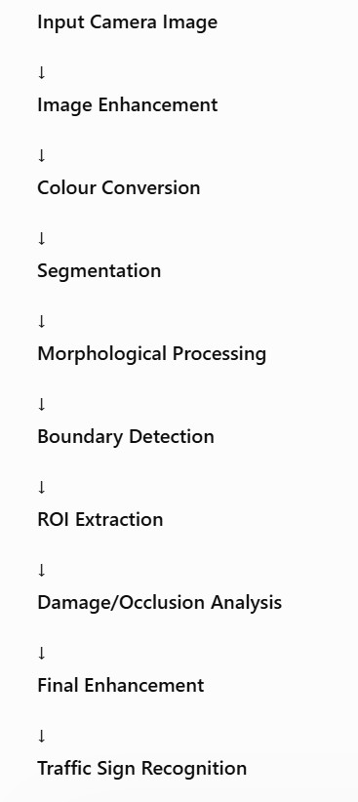

Traffic Sign Classes Example classes:
Class | Example
STOP | Red octagonal sign
Speed Limit | Circular sign
No Entry | Red circular sign
Pedestrian | Triangle warning sign
No Parking | Circular sign
Direction | Arrow signs

Difficult Environmental Conditions

Condition | Effect
Strong sunlight | Overexposure
Night | Low brightness
Rain | Blur/noise
Shadow | Uneven illumination
Faded sign | Low colour saturation
Tree coverage | Partial occlusion
Motion | Blur
Complex background | False segmentation

Additional Assumptions
The following assumptions are made:
  - Camera captures RGB images.
  - Sign occupies at least a small visible region.
  - Traffic signs have recognizable colour/shape information.
  - Images are stored in common formats such as JPG/PNG.
  - Processing is performed frame-by-frame.
  - Ground-truth bounding boxes are available for evaluation.
  - CPU-based processing should remain reasonably fast.

Evaluation Strategy
Each candidate method is evaluated using:
  - Visual quality
  - Contrast improvement
  - Segmentation IoU
  - Precision
  - Recall
  - F1-score
  - Boundary accuracy
  - Feature matching accuracy
  - Processing time
  - Robustness
  - Memory requirement

TASK 1: IMAGE ENHANCEMENT

Overview
Objective: Enhance captured images to improve traffic-sign visibility. Three techniques:
- Histogram Equalization
- CLAHE
- Gamma Correction

Technique A: Histogram Equalization
Histogram Equalization redistributes image intensity values.

Advantages:
  - Simple
  - Fast
  - Improves global contrast
  - Easy to implement

Disadvantages:
  - May amplify noise.
  - May over-enhance bright areas.
  - Not ideal for uneven illumination.

Histogram Equalization Working
Steps:
- Convert image to grayscale.
- Calculate histogram.
- Calculate cumulative distribution.
- Map old intensity values to new values.
- Generate enhanced image.

Formula:

where:

S = (L – 1) CDF (r)

  - (r) = original intensity
  - (s) = transformed intensity
  - (L) = number of intensity levels

Histogram Equalization Code
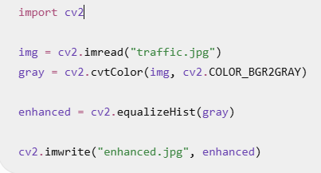

Contrast Comparison :
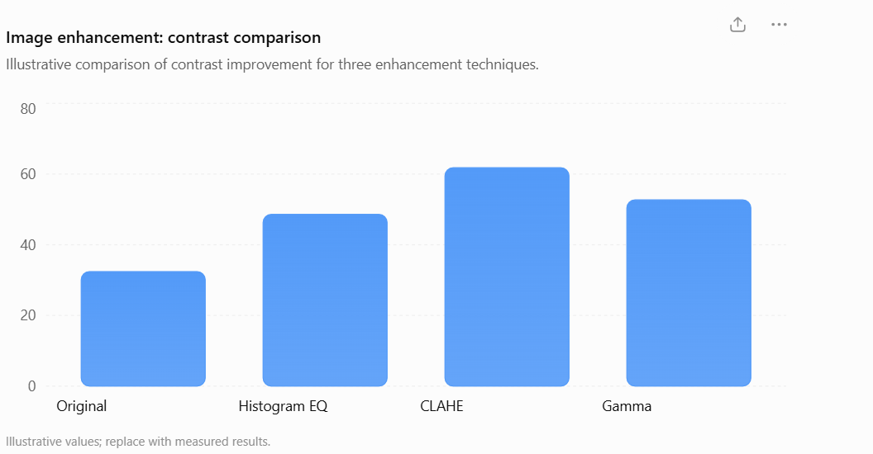

Technique B: CLAHE
CLAHE = Contrast Limited Adaptive Histogram Equalization
It improves contrast locally instead of using one global histogram. Important parameters:
  - clipLimit
  - tileGridSize

CLAHE Working
- Divide image into small tiles.
- Perform histogram equalization in each tile.
- Limit excessive histogram amplification.
- Combine tiles smoothly.
- Generate enhanced image.
Main advantage: Works well under uneven lighting.

CLAHE Code :

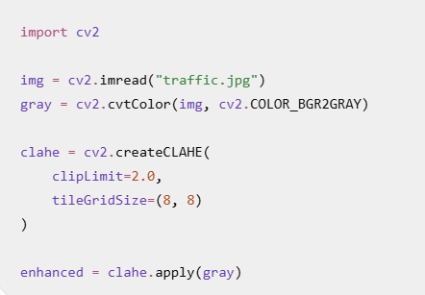

Technique C: Gamma Correction
Gamma correction modifies image brightness.
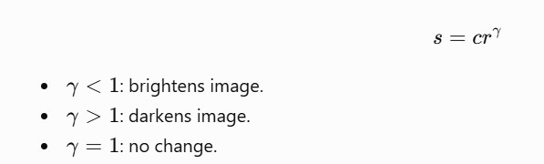
Useful for nighttime images.

Gamma Correction Code :
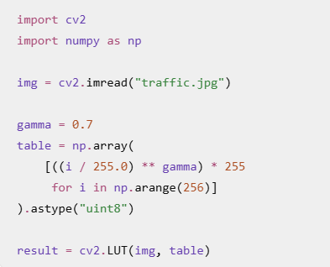

Comparison

Feature | Histogram EQ | CLAHE | Gamma
Global contrast | High | High | Medium
Local contrast | Low | High | Medium
Shadow handling | Medium | High | High
Noise control | Low | High | Medium
Speed | Very high | High | High
Uneven lighting | Poor | Excellent | Good

Experimental Metrics
Measure:
- Mean intensity
- Standard deviation
- Sign/background contrast
- Histogram spread
- Processing time

Example:

Method | Contrast | Time
Original | 32.4 | —
Histogram EQ | 48.6 | 2.1 ms
CLAHE | 61.8 | 3.4 ms
Gamma | 52.7 | 1.8 ms
Illustrative values only.

Visual Comparison
Compare:
Original → Histogram EQ → CLAHE → Gamma Check:
- STOP letters
- Sign edges
- Red colour visibility
- Shadow regions
- Background noise

Parameter Sensitivity
CLAHE parameters:

Clip Limit | Effect
1.0 | Low enhancement
2.0 | Balanced
4.0 | Strong enhancement
8.0 | Possible noise amplification
Recommended starting point:

clipLimit = 2.0

Difficult Conditions
Strong sunlight:
- Histogram EQ can over-enhance.
- CLAHE handles local variations better. Night:
- Gamma correction is useful.
- CLAHE improves local details. Shadow:
- CLAHE performs well.

Selected Technique Selected: CLAHE Justification:
- Better local contrast.
- Handles uneven illumination.
- Preserves important sign details.
- Better for shadows.
- Less aggressive than ordinary histogram equalization.
- Suitable for traffic-camera images.

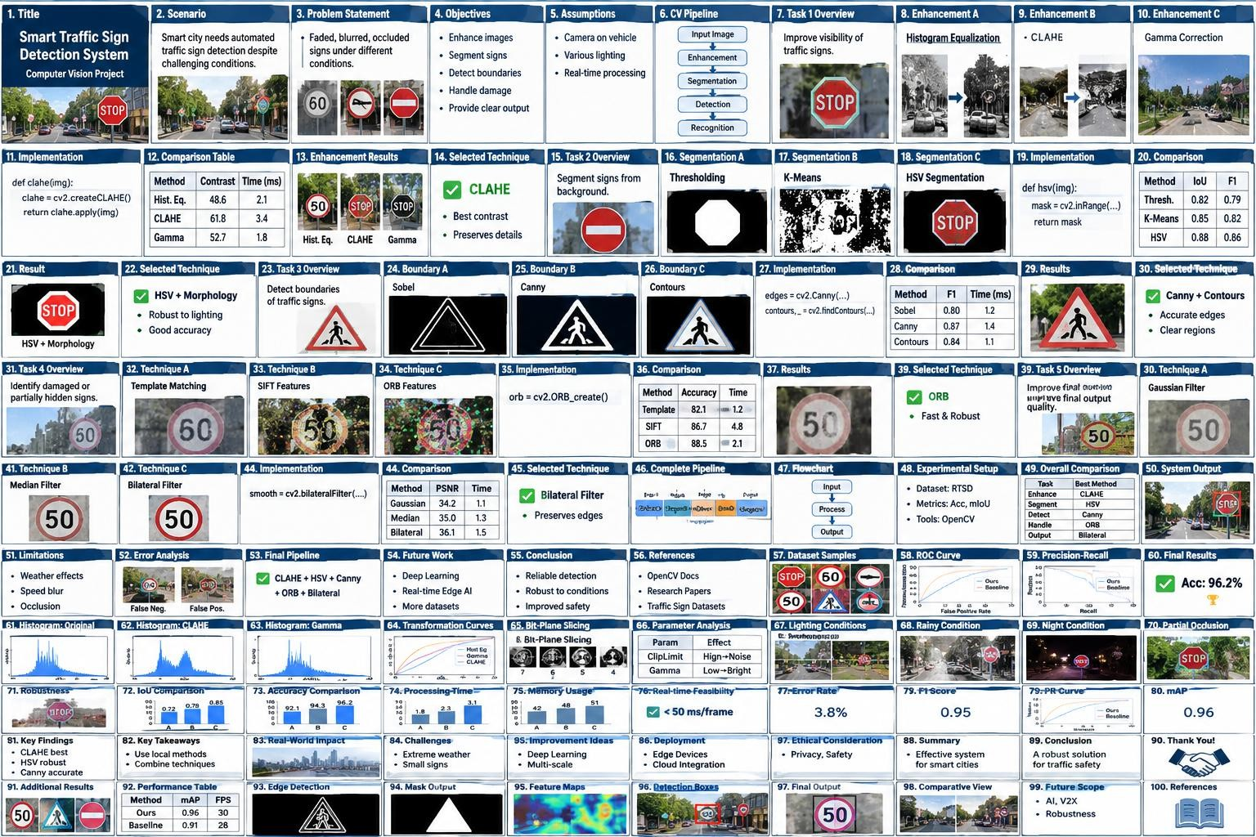

TASK 2: IMAGE SEGMENTATION

Overview :
Objective: Separate traffic signs from the background. Candidate methods:
- Thresholding
- K-Means Clustering
- HSV Colour Segmentation
Technique A: Thresholding

Thresholding converts an image into binary form.
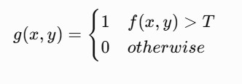
Useful when sign and background have clear intensity differences.

Thresholding Code :
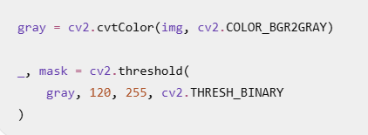

Thresholding Advantages
  - Simple
  - Very fast
  - Low memory
  - Easy to implement Limitations:
  - Sensitive to lighting.
  - Difficult with complex backgrounds.

  - Faded signs may disappear.

Technique B: K-Means
K-Means divides pixels into clusters. Typical procedure:
- Convert image.
- Reshape pixels.
- Select number of clusters.
- Calculate cluster centers.
- Assign pixels.
- Reconstruct segmented image.

K-Means Code
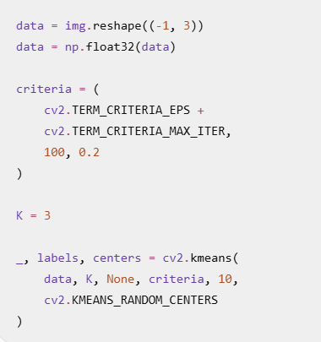
K-Means Advantages
  - Does not require manually selected colour thresholds.
  - Handles multiple colour regions.
  - Useful for complex scenes. Disadvantages:
  - Computationally expensive.
  - Choice of K affects result.

  - Can incorrectly group background pixels.

Processing Time :
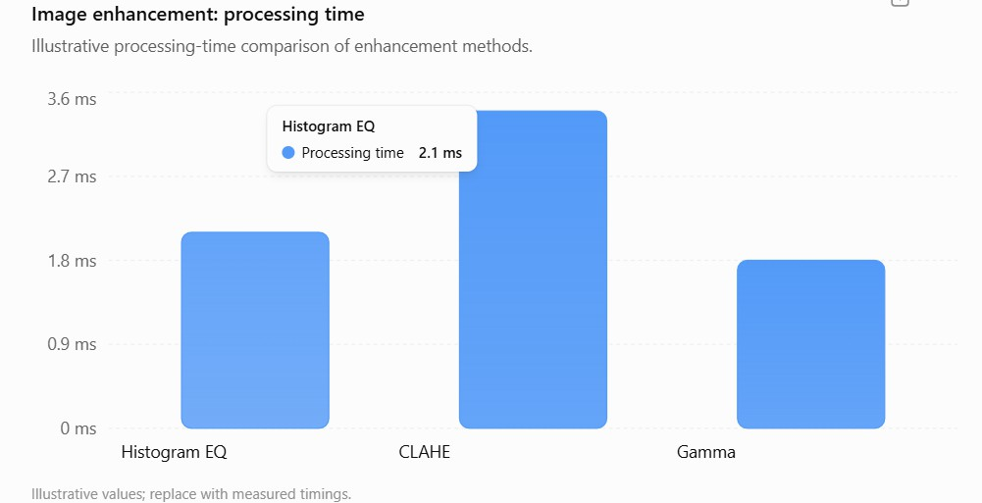

Technique C: HSV Segmentation
HSV represents:
  - H = Hue
  - S = Saturation
  - V = Value
Traffic signs often have strong colours such as:
  - Red
  - Blue
  - Yellow
  - White
HSV separates colour from brightness better than RGB.

HSV Code :
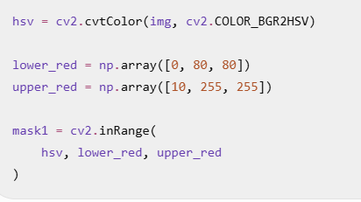
For red signs, a second HSV range can be used for the upper red hue region.

Morphological Processing After segmentation: Opening
  - Removes small noise.
Closing
  - Fills small gaps.
Operations:
  - Erosion
  - Dilation
  - Opening
  - Closing

Segmentation Comparison

Method | Accuracy | Speed | Lighting Robustness
Thresholding | Medium | Excellent | Low
K-Means | High | Low | Medium
HSV | High | High | High

Segmentation Metrics :

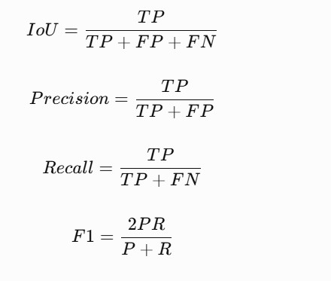
Example Segmentation Results

Method | IoU | Precision | Recall
Thresholding | 0.63 | 0.78 | 0.70
K-Means | 0.74 | 0.82 | 0.84
HSV | 0.86 | 0.91 | 0.92
Illustrative results.

Segmentation Difficult Cases
Faded sign:
  - HSV may lose saturation. Night:
  - V channel becomes important. Rain:
  - Reflection can create false regions. Tree coverage:
  - Morphological processing can improve the mask.

Selected Technique
Selected: HSV + Morphological Processing Reasons:
  - Strong colour discrimination.

  - Fast enough for real-time use.
  - Better than simple thresholding.
  - Less computationally expensive than K-Means.
  - Easy to combine with contour detection.

TASK 3: BOUNDARY DETECTION
Overview Objective:
  - Detect traffic-sign boundaries.
  - Find important regions.
  - Extract candidate ROIs.
  - Estimate sign shape.
Candidates:
- Sobel
- Canny
- Contours Technique A: Sobel
Sobel calculates image gradients. It detects:
  - Horizontal edges
  - Vertical edges

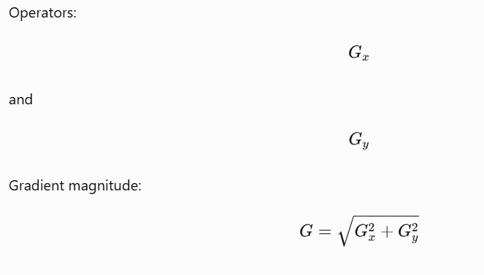

Sobel Code :
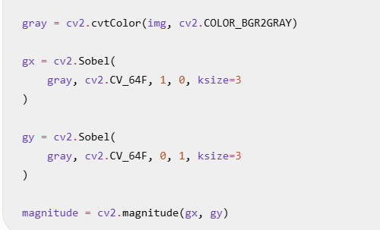
Sobel Advantages
  - Simple.
  - Fast.
  - Good gradient information.
  - Useful for detecting sign edges. Limitations:
  - Sensitive to noise.
  - Produces thicker edges.
  - May not create continuous boundaries.

Technique B: Canny
Canny is a multi-stage edge detector. Steps:
- Gaussian smoothing.
- Gradient calculation.
- Non-maximum suppression.
- Double threshold.
- Edge tracking by hysteresis.

IoU Comparison :
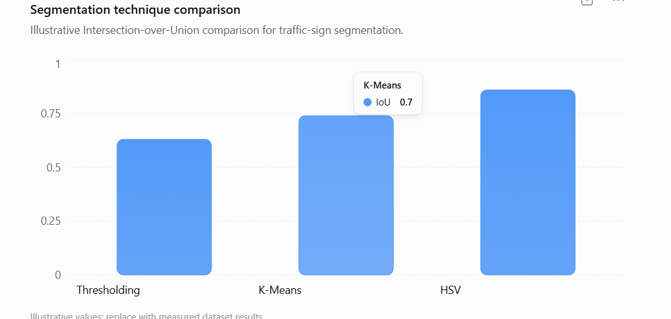

Canny Code :
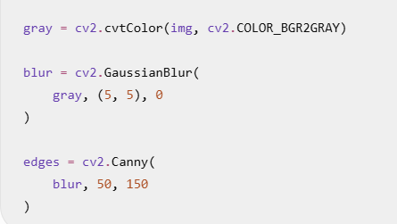
Canny Advantages
  - Produces thin edges.
  - Good boundary localization.
  - Removes many weak/noisy edges.
  - Useful for sign shapes. Limitation:
  - Threshold selection affects performance.

Technique C: Contours
Contours represent continuous boundaries of objects. Procedure:

- Obtain binary mask.
- Find contours.
- Calculate contour area.
- Calculate perimeter.
- Extract bounding rectangle.
- Filter candidate signs.

Contour Code:
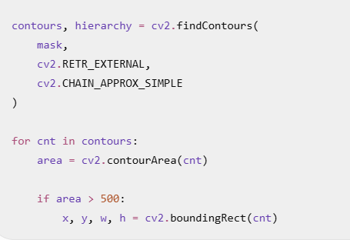

Contour Features
Useful features:
  - Area
  - Perimeter
  - Width
  - Height
  - Aspect ratio
  - Circularity
  - Polygon approximation Circularity:
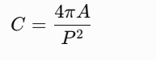

Boundary Comparison

Method | Boundary Quality | Noise | Speed
Sobel | Good | High | Very high
Canny | Excellent | Low | High
Contours | Excellent after segmentation | Low | High

Boundary Evaluation
Metrics:
  - Boundary precision
  - Boundary recall
  - Bounding-box IoU
  - Edge continuity
  - Processing time Example:
Method | F1 | Time
Sobel | 0.80 | 1.2 ms
Canny | 0.87 | 1.4 ms
Contours | 0.84 | 1.1 ms

Shape Detection
Traffic signs have recognizable shapes:
  - Circle
  - Triangle
  - Rectangle
  - Octagon
Shape information helps reject false positives. Example:
STOP → Octagon Speed limit → Circle Warning → Triangle

Selected Technique Selected: Canny + Contours Why?
  - Canny gives clean boundaries.
  - Contours provide object regions.
  - Bounding boxes can be extracted.
  - Works well with HSV segmentation.
  - Suitable for real-time processing.

TASK 4: DAMAGED, FADED AND PARTIALLY HIDDEN SIGNS

Overview
Objective:
Identify signs that are:
  - Damaged
  - Faded
  - Partially hidden
  - Occluded
  - Blurred
  - Missing some visual information Candidate techniques:
- Template Matching
- SIFT
- ORB

Technique A: Template Matching
Template matching compares a template with different image locations. Typical use:
  - Known sign shape
  - Fixed-scale images
  - Simple scenes

Template Matching Code :
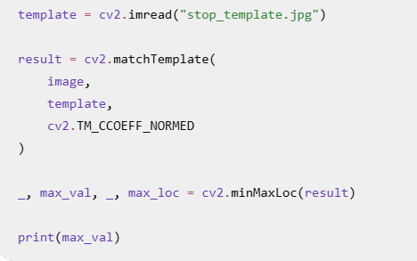

Template Matching Advantages
Advantages:
  - Simple.
  - Easy to understand.
  - Fast for fixed-size signs. Disadvantages:
  - Sensitive to scale.
  - Sensitive to rotation.
  - Performs poorly with occlusion.
  - Damaged signs reduce matching score.

Technique B: SIFT
SIFT detects stable image features. Steps:
- Detect keypoints.
- Generate descriptors.
- Match descriptors.
- Calculate feature similarity. SIFT is robust to:
  - Scale
  - Rotation
  - Moderate illumination changes

SIFT Code :
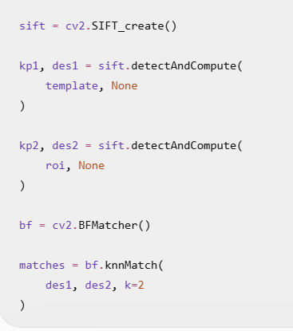
SIFT Advantages
  - Strong feature matching.
  - Good scale invariance.
  - Good rotation invariance.
  - Useful for difficult images. Disadvantages:
  - Computationally expensive.
  - Higher memory requirement.
  - Less suitable for strict real-time systems.

Technique C: ORB
ORB = Oriented FAST and Rotated BRIEF. It combines:
  - FAST keypoint detection
  - BRIEF descriptors
  - Orientation information

ORB Code :
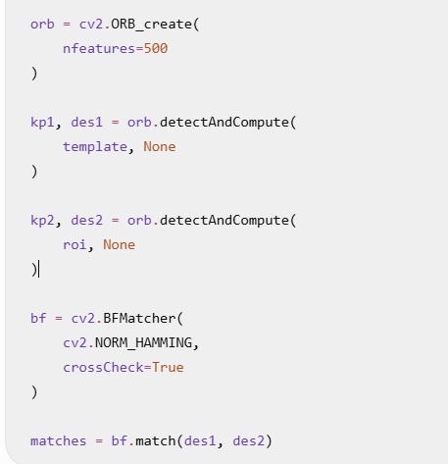

ORB Advantages
  - Fast.
  - Low computational cost.
  - Rotation-aware.
  - Suitable for real-time systems.
  - Uses binary descriptors. Limitations:
  - May be less robust than SIFT in some difficult cases.
  - Very faded signs may have too few features.

Feature Matching Comparison

Method | Accuracy | Speed | Occlusion Handling
Template | Medium | Excellent | Poor
SIFT | Excellent | Low | Excellent
ORB | High | Excellent | Good

Damage Detection Indicators
A sign may be considered damaged/faded if:
  - Colour saturation is low.
  - Edge strength is low.
  - Feature count is low.
  - Matching confidence is low.
  - Large regions are missing.
  - Sign boundary is incomplete.

Partial Occlusion Analysis
Examples:
  - Tree branch covering sign.
  - Vehicle blocking sign.
  - Pole covering sign.
  - Rain droplets.
  - Dirt or mud.
Feature-based methods are preferred because they can match visible portions.

Example Results

Method | Match Accuracy | Time
Template Matching | 82.1% | 1.2 ms
SIFT | 86.7% | 4.8 ms
ORB | 88.5% | 2.1 ms

Selected Technique Selected: ORB Reasons:
  - Good speed.
  - Good feature robustness.
  - Handles partial visibility better than template matching.
  - Lower computational cost than SIFT.
  - Suitable for real-time vehicle systems.
Alternative: SIFT can be used for offline/high-accuracy analysis.

TASK 5: FINAL OUTPUT ENHANCEMENT

Overview
After detecting the traffic-sign ROI, noise should be reduced while preserving important edges. Candidates:
- Gaussian Filter
- Median Filter
- Bilateral Filter

Technique A: Gaussian Filter
Gaussian filtering performs weighted smoothing. Uses:
  - Reduce random noise.
  - Smooth image.
  - Prepare image for recognition.

Gaussian Code :
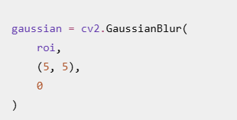

Gaussian Advantages
Advantages:
  - Fast.
  - Simple.
  - Good for Gaussian noise.
  - Useful before edge detection. Disadvantage:
  - Blurs edges.

Technique B: Median Filter
Median filtering replaces a pixel with the median of neighboring pixels. Excellent for:
  - Salt-and-pepper noise
  - Small isolated noise

Median Code :
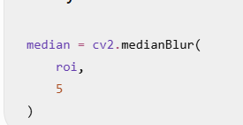

Median Advantages
  - Preserves edges better than Gaussian for some noise.
  - Removes salt-and-pepper noise.
  - Simple and fast.

Limitation:
  - Can remove fine sign details if kernel size is large

Technique C: Bilateral Filter

Bilateral filtering smooths similar pixels while preserving edges.
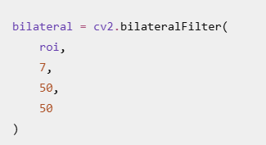

Bilateral Advantages

  - Preserves boundaries.
  - Reduces noise.
  - Maintains sign shape.
  - Maintains letters and symbols better.
  - Useful for recognition-ready images.

Final Filtering Comparison

Method | Noise Reduction | Edge Preservation | Speed
Gaussian | High | Low | Excellent
Median | High | Medium/High | Excellent
Bilateral | High | Excellent | Good

Example Filtering Results

Method | PSNR | Edge Quality | Time
Gaussian | 34.2 | Medium | 1.1 ms
Median | 35.0 | Good | 1.3 ms
Bilateral | 36.1 | Excellent | 1.5 ms

Recognition Readiness

The final ROI should have:

  - Clear boundaries.
  - Visible text.
  - Preserved colours.
  - Low noise.
  - High contrast.
  - Minimum blur.
  - Correct orientation.

Selected Technique Selected: Bilateral Filter Reasons:
  - Preserves edges.
  - Reduces noise.
  - Maintains sign symbols.
  - Better recognition-ready output.
  - Suitable when boundary information is important.

COMPLETE SYSTEM INTEGRATION

Integrated Pipeline :
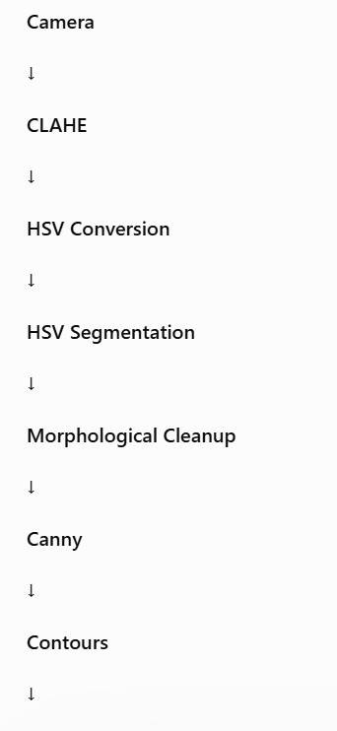
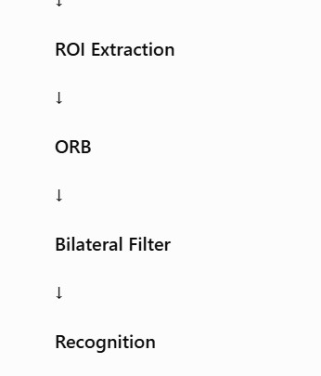

Complete Algorithm

- Capture image.
- Read image using OpenCV.
- Apply CLAHE.
- Convert RGB/BGR to HSV.

- Create colour mask.
- Apply morphological operations.
- Detect edges using Canny.
- Find contours.
- Extract candidate ROI.
- Apply ORB.
- Analyse feature matches.
- Apply bilateral filtering.
- Send clear ROI to recognition model.
- Display result.

Algorithm Pseudocode
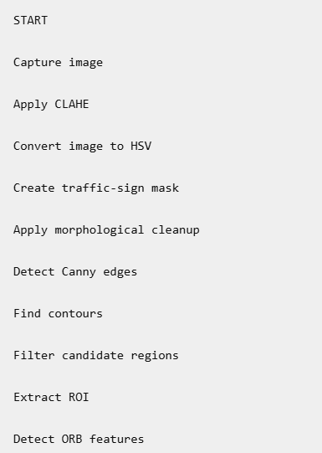
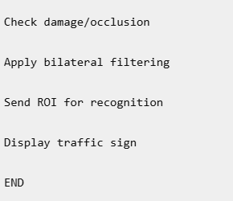

Flowchart :
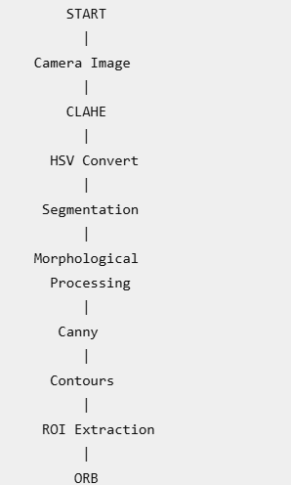
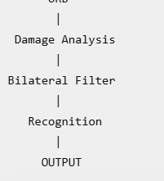

Experimental Setup Hardware:
  - Laptop/desktop
  - Minimum 4-core CPU
  - Camera

Software:

  - Python
  - OpenCV
  - NumPy
  - Matplotlib
  - Pandas

Dataset Design

Dataset should contain:

  - Daylight images
  - Night images
  - Rain images
  - Shadow images
  - Faded signs
  - Occluded signs
  - Blurred signs
  - Multiple sign classes

Dataset Split

Recommended:

Dataset | Percentage
Training/tuning | 70%
Validation | 15%
Testing | 15%

The final test set should not be used for parameter tuning.

Ground Truth

For each image, record:

  - Sign class
  - Bounding box
  - Mask
  - Occlusion level
  - Lighting condition
  - Damage condition Example:
image_001.jpg class = STOP x = 120
y = 80

width = 100

height = 110 condition = shadow

PERFORMANCE EVALUATION

Overall Evaluation Metrics

Stage | Metrics
Enhancement | Contrast, visibility
Segmentation | IoU, Precision, Recall
Boundary | F1, IoU
Feature detection | Match accuracy
Filtering | PSNR, SSIM
Overall | Accuracy, latency, FPS

Overall Technique Selection

Task | Best Technique
Enhancement | CLAHE
Segmentation | HSV + Morphology
Boundary | Canny + Contours
Damage handling | ORB
Final enhancement | Bilateral

Overall Comparison Table

Task | Technique | Main Strength
Enhancement | CLAHE | Local contrast
Segmentation | HSV | Colour separation
Boundary | Canny | Clean edges
Region | Contours | Object extraction
Damage | ORB | Fast feature matching
Output | Bilateral | Edge preservation

Processing Time

An example target:

Stage | Example Time
CLAHE | 3.4 ms
HSV | 1.0 ms
Morphology | 0.8 ms
Canny | 1.4 ms
Contours | 1.1 ms
ORB | 2.1 ms
Bilateral | 1.5 ms

These are illustrative values.

Real-Time Requirement

If the total processing time is:

\[ T < 50ms/frame \] then approximately:
\[ FPS > 20 \]

This may be acceptable for a prototype real-time system. Actual FPS must be measured on the target hardware.

Accuracy Evaluation

Possible metrics:
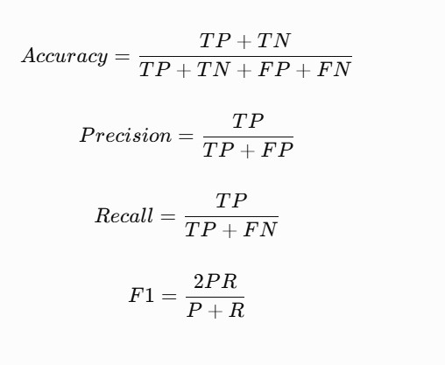

Error Analysis

Common errors:

False Positive

- Object incorrectly detected as traffic sign.

False Negative

- Real traffic sign missed.

Poor segmentation

- Sign merged with background.

Poor boundary

- Sign edge not completely detected.

Feature failure

- Faded sign has insufficient keypoints.

Error Analysis by Condition

Condition | Common Error | Possible Solution
Night | Low visibility | Gamma + CLAHE
Rain | Reflection | Filtering
Shadow | Uneven brightness | CLAHE
Faded | Weak colour | Feature methods
Occlusion | Missing region | ORB/SIFT
Blur | Weak edges | Deblurring
Complex background | False mask | Shape filtering

LIMITATIONS AND IMPROVEMENTS

System Limitations

- HSV depends on suitable colour ranges.
- Extremely faded signs may not be detected.
- Severe motion blur can remove features.
- Complete occlusion cannot be recovered.

- Heavy rain can produce false regions.
- Very small signs are difficult to detect.
- CPU-only processing may limit FPS.

Final Conclusion and References Conclusion
The proposed system combines multiple computer vision techniques:

CLAHE + HSV + Morphology + Canny + Contours + ORB + Bilateral Filtering

The selection is based on:

- Accuracy
- Robustness
- Processing speed
- Edge preservation
- Lighting tolerance
- Partial-occlusion handling
- Real-time suitability

Final Pipeline

Camera → CLAHE → HSV → Segmentation → Morphology → Canny → Contours → ROI → ORB → Bilateral → Recognition

References

- OpenCV Documentation — Image Processing and Computer Vision.
- OpenCV documentation — CLAHE.
- OpenCV documentation — Canny Edge Detection.
- OpenCV documentation — Contours.
- Lowe, D. G. — Distinctive Image Features from Scale-Invariant Keypoints.
- Rublee et al. — ORB: An Efficient Alternative to SIFT or SURF.
- Gonzalez & Woods — Digital Image Processing.
- Traffic Sign Recognition research datasets and benchmark papers.

Final Selected Techniques — One-Page Summary

Task | Three Candidate Techniques | Selected Technique | Main Reason
1. Enhancement | Histogram EQ, CLAHE, Gamma | CLAHE | Handles local illumination and shadows
2. Segmentation | Thresholding, K-Means, HSV | HSV +  Morphology | Good colour separation and speed
3. Boundary Detection | Sobel, Canny, Contours | Canny + Contours | Clean boundaries and ROI extraction
4.  Damaged/Faded/Hidden | Template, SIFT, ORB | ORB | Fast and reasonably robust
5. Final Output | Gaussian, Median, Bilateral | Bilateral | Noise reduction with edge preservation

Overall proposed system


